FOR IMMEDIATE RELEASE
Female Founder and Dreamology Labs Sue MSC Cruises and Chairman Pierfrancesco Vago, Seeking Nearly $1.9 Billion Over Alleged IP Theft and Sexual Exploitation
Complaint alleges a long pattern of fraudulent inducement and NDA-protected IP misuse, including an award-winning attraction credited to Vago as “creative driver”
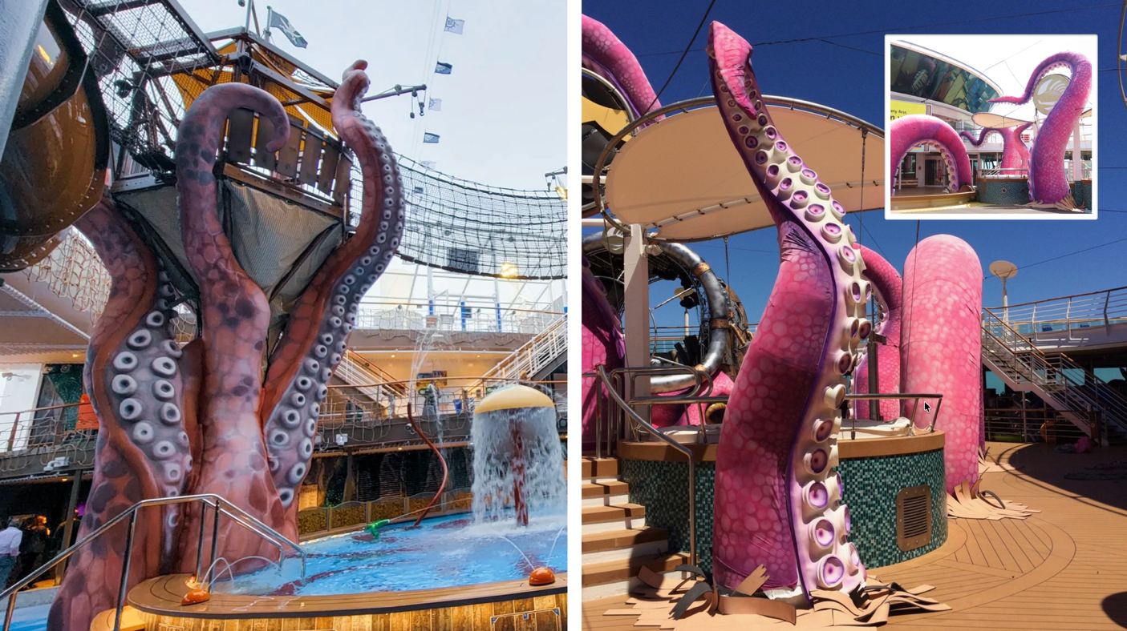
Pictured: (Left) MSC Cruises’ Pirates Cove Aquapark; (Right) Shipsomnia’s Tale of the Kraken.
Exhibit 20 to the Complaint, filed in the U.S. District Court for the Southern District of Florida.
MIAMI – (June 4, 2026) Alessandra Maderni, founder and CEO of Dreamology Labs, Inc., has filed a federal lawsuit in the U.S. District Court for the Southern District of Florida against MSC Cruises, MSC Cruises USA, and MSC Executive Chairman Pierfrancesco Vago, alleging a years-long pattern of fraudulent business inducement, intellectual property theft, and sexual coercion.
The complaint alleges that Maderni and Dreamology Labs spent years developing proprietary experiential entertainment IP and travel-technology ventures, including the Shipsomnia franchise and XploraWorld platform. At a formal NDA-protected presentation in Geneva in September 2019, former senior Disney executives personally endorsed the Shipsomnia venture directly to Vago and MSC executives.
According to the lawsuit, between 2019 and 2025, Vago and MSC executives obtained Plaintiffs' confidential creative, commercial, and strategic materials under nondisclosure agreements and repeated assurances of potential multi-million-dollar partnerships and cruise integrations.
The suit claims that after obtaining access to confidential materials, MSC launched at least four onboard attractions and entertainment offerings aboard multiple vessels that allegedly incorporated Plaintiffs’ proprietary IP and commercialization strategies without credit or compensation.
Among the offerings is Pirates Cove Aquapark — recipient of the 2023 World Waterpark Association Leading Edge Award for creativity and innovation — for which a vendor case study credited Vago as 'creative driver' without referencing Plaintiffs or their NDA-protected Shipsomnia materials.
"Initially planned as an intergalactic adventure-themed water park, it was MSC Cruises' Executive Chairman, Pierfrancesco Vago, who pushed the team to dream bigger... He recommended incorporating a pirate ship and the imagery of a giant Kraken... making them the main characters in an exciting pirate story."
— WhiteWater, Pirates Cove Aquapark vendor case study
Central to the complaint is the allegation that this was not a conventional IP dispute, but an integrated pattern in which business inducement, sexual coercion, and misuse of corporate authority were intertwined. Plaintiffs allege Vago used promises of funding and partnership to extract proprietary business value and sexual access, while prolonging Plaintiffs’ reliance through cycles of inducement, disclosure, withdrawal, and continued use of their IP.
The complaint asserts eleven causes of action, including trade secret misappropriation, copyright infringement, breach of NDA, fraudulent inducement, civil sexual battery, civil sex trafficking, Florida Civil RICO, and related claims. An independent preliminary but-for analysis estimates damages at nearly $1.9 billion, subject to discovery and expert analysis. The valuation is not a court finding or damages award.
About Dreamology Labs
Dreamology Labs, Inc. is an experiential entertainment IP and travel-technology company founded by Alessandra Maderni. Through brands including Shipsomnia, Culturepunk, and XploraWorld, the company produces immersive concepts that bring together travel, storytelling, culture, technology, and ESG-driven impact in support of a more sustainable and equitable creator economy.
Resources
Full complaint with exhibits, media kit and case summary: www.dreamologylabs.com/presskit
Dreamology Labs Inc. www.dreamologylabs.com
Case 1:26-cv-23846-DPG | All claims are allegations. Defendants have not yet filed a response.
Media Contact: info@dreamologylabs.com | For television, podcast, radio, print, and speaking inquiries: info@dreamologylabs.com
Legal Inquiries: John M. Pierce, John Pierce Law, P.C. | (321) 292-2366 | jpierce@johnpiercelaw.com

